**Customer Churn Prediction**

**Project Definition:**

The project involves using IBM Cognos to predict customer churn and identify factors influencing customer retention. The goal is to help businesses reduce customer attrition by understanding the patterns and reasons behind customers leaving. This project includes defining analysis objectives, collecting customer data, designing relevant visualizations in IBM Cognos, and building a predictive model.

**Design Thinking:**

**Analysis Objectives:**

**1.Identify Potential Churners :**

Develop a predictive model that can accurately identify customers who are at high risk of churning. The objective is to assign a churn probability score to each customer.

**2. Understand Key Factors Contributing to Churn:**

Perform an in-depth analysis to identify and rank the key factors and variables that significantly contribute to customer churn. This should provide insights into why customers are leaving.

**3. Segmentation for Targeted Retention Strategies:**

Segment the customer base based on their churn risk and characteristics. This will enable the development of targeted retention strategies for different customer groups.

**Data Collection :**

**1.Customer Demographics:**

Collect demographic data such as age, gender, location, and income to understand if these factors influence churn.

**2. Usage Behaviour:**

Gather data on how frequently customers use the product or service, what features they use most, and their overall engagement**.**

**3. Historical Interactions:**

Collect historical data on customer interactions, including customer support tickets, feedback, and complaints**.**

**4. Billing and Subscription Data:**

Include information on subscription plans, billing history, and payment patterns.

**5. Customer Feedback and Surveys:**

If available, incorporate qualitative data from customer surveys or feedback forms to gain deeper insights**.**

**Visualization Strategy:**

**1.Churn Dashboard:**

Create an interactive dashboard in IBM Cognos that displays real-time churn predictions. Include visualizations such as line charts showing historical churn rates and pie charts illustrating the distribution of churners vs. non-churners.

**2. Factor Analysis Visualization:**

Use bar charts or heatmaps to visually represent the importance of different factors contributing to churn. Create interactive visualizations that allow stakeholders to explore how each factor impacts churn.

**3. Segmentation Visualizations:**

Develop scatter plots or bubble charts to show customer segmentation based on churn risk and demographics. Use colour coding to differentiate segments.

**4. Retention Strategies Heatmap:**

Visualize the effectiveness of different retention strategies over time using a heatmap. This can help in identifying which strategies are most successful in reducing churn.

**Predictive Modelling:**

**1.Algorithm Selection:**

Choose machine learning algorithms suitable for classification tasks, such as Logistic Regression, Random Forest, Gradient Boosting, or Neural Networks. Experiment with multiple algorithms to find the best-performing one.

**2. Feature Selection:**

Select relevant features for the predictive model. This may include demographic variables, usage patterns, historical interactions, and customer feedback.

**3. Data Split:**

Split the data into training and testing sets for model development and evaluation, ensuring that the data is representative and balanced.

**4. Model Evaluation:**

Use appropriate evaluation metrics such as accuracy, precision, recall, F1-score, and ROC-AUC to assess the model's performance. Implement cross-validation techniques to ensure robustness.

**5. Hyperparameter Tuning:**

Optimize the hyperparameters of the selected model to achieve the best predictive accuracy**.**

**6. Model Deployment:**

Once the model is trained and evaluated, deploy it in a production environment integrated with IBM Cognos for real-time or batch predictions.

By defining these objectives, data collection methods, visualization strategies, and predictive modelling approaches, you will be well-prepared to tackle the challenge of predicting customer churn and understanding the factors influencing it using IB Cognos as a powerful analytics tool

**Diagrams for phases of Customer Churn Prediction:**

**a)Analysis:**

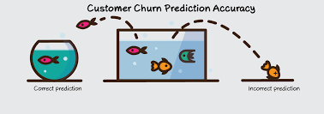

**b)Data Collection:**

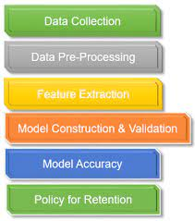

**c)Visualization Strategy:**

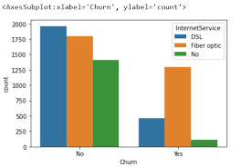

**d)Prediction:**

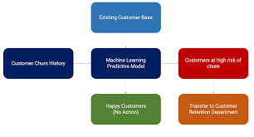

**Dataset Link:**

[**https://www.kaggle.com/datasets/blastcher/teleco-customer-churn**](https://www.kaggle.com/datasets/blastcher/teleco-customer-churn)

**Machine Learning Model Evaluations and Predictions:**

There are some ways to predicted the evaluations that are listed below,

1. KNN.
2. SVC.
3. Random Forest.
4. Logistic Regression.
5. Decision Tree Classifier.
6. Ada Boost Classifier.
7. Gradient Boosting Classifier.
8. Voting Classifier.

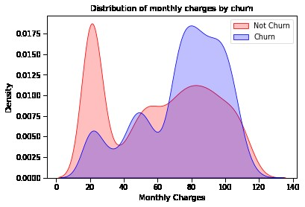

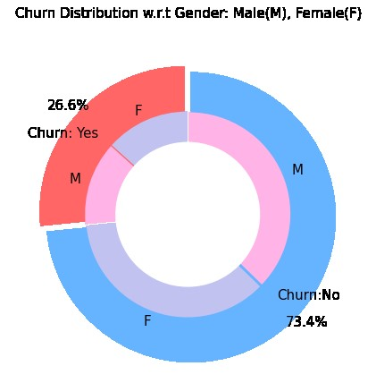

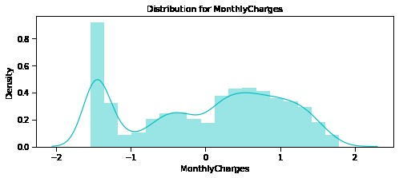

**Conclusion:**

At the end we can predict the churn by using the above given methods and the innovation is to build the complete customer churn prediction model in telecom industry. We use many ML algorithms and using the methods to predict the customer churn.